CASP-ICE Community Sampling Initiative 2026
Methods and sampling approach
Prepared by | Chris Williamson (c.williamson@bristol.ac.uk)  CASP-ICE (www.casp-ice.org.uk)
Project aim | Coordinated community sampling of snow and glacier algal blooms to build an open-source global ground-truth dataset matched to remote sensing products.
Intended users | Field teams contributing sampling during the 2026/27 (austral) spring/summer seasons
Status | Draft for comment and amendment

1. Rationale and overall objectives
This CASP-ICE community sampling initiative is intended to generate an open-source, cross-site dataset of snow and glacier algal abundance that can be paired with remotely sensed observations. The longer-term aims are to improve ground truthing for remote sensing/modelling products, increase knowledge on bloom ecology and phenology, and produce a shared community resource that captures bloom development across different regions, elevations, seasons, and glaciological settings.

2. Sampling-design rationale
Our intention here is to capture both the spatial structure of sampled blooms and to get a high-accuracy estimate of the spatial average of algal abundance. The former requires sampling across a range of spatial intervals, and both require high replication. For example, we have recently shown through high-resolution field sampling (n = 200) and subsequent simulations that high error is associated with low replication when trying to capture the true spatial mean of blooms (Table 1).
Table 1: Percent Mean Average Error (MAE% ± SD) of different sampling replications for simulated early, mid and late bloom stages with spatial ranges of 2.5, 4.7 and 7 m, respectively.
Replication (n) | Early bloom MAE % | Mid bloom MAE % | Late bloom MAE%
3 | 49.3 ± 33.1 | 46.4 ± 30.0 | 18.1 ± 12.8
5 | 37.1 ± 26.0 | 31.6 ± 26.2 | 13.9 ± 11.0
10 | 31.6 ± 23.1 | 26.5 ± 18.8 | 10.1 ± 7.3
25 | 17.0 ± 11.7 | 15.3 ± 11.1 | 5.4 ± 4.5
50 | 13.5 ± 9.3 | 11.0 ± 8.6 | 4.2 ± 2.9
100 | 7.5 ± 5.4 | 7.4 ± 6.2 | 3.2 ± 2.7

3. Sampling-design details
After assessing multiple sampling designs and considering the trade off between the spatial distribution of sampling points and the number of replicates required, a nested grid design (Figure 1a) offers the most effective balance between the two, i.e. an adequate distribution of sampling intervals for spatial structure analysis, good spatial coverage across the sampling area, and as low n as possible. The intention here is to do n = 3 to n = 5 of these grids per snowpack / region of glacier being surveyed (Figure 1b). This would result in a total sample replication of n = 51 (for 3 grids) to n = 85 (for 5 grids) distributed over the survey area, which would give very high statistical power for spatial structure and spatial average determination.
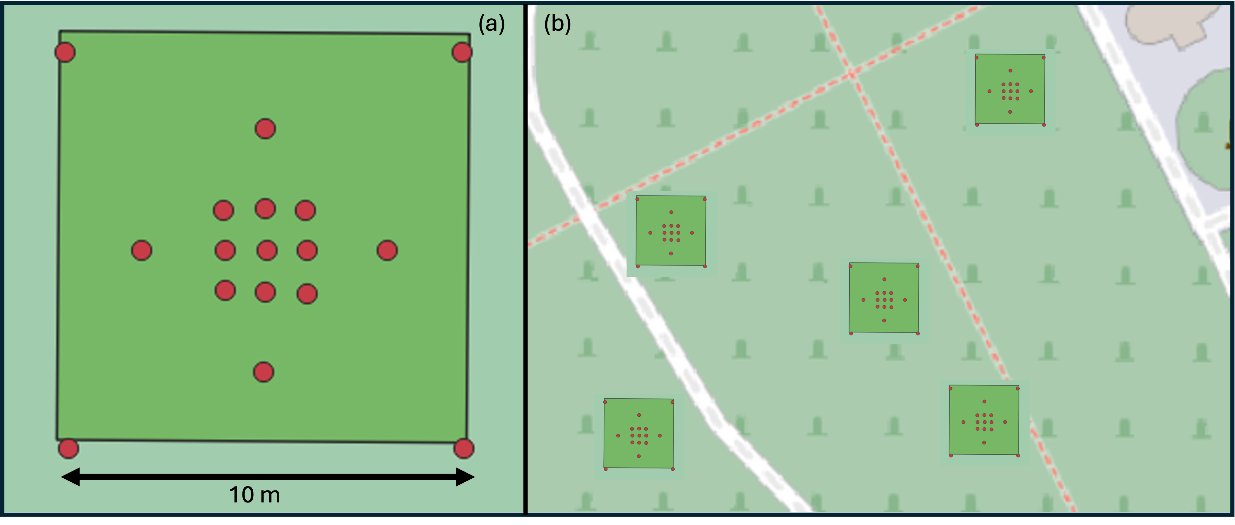
Figure 1: Proposed nested grid sampling design, showing (a) sampling grid design (red dots, n = 17) distributed over a 10 x 10 m sampling area, and (b) replicated grids distributed across the broader survey area. The intention here is to undertake n = 3 to n = 5 sampling grids per snowpack / region of glacier being surveyed.
Each grid is composed of 4 corner samples (spanning a 10 x 10 m square); 4 intermediate samples distributed at the middle (5 m) of each edge 2 m into the sampling area; and an inner central grid of 9 samples spaced 1 m from each other. The position (coordinates) of each sample location relative to the bottom left-hand corner is shown in Figure 2. *N.B. if the available sampling area is smaller than 10 x 10 m, this can be scaled proportionally to fit within the sampling area (e.g. smaller snow patches).
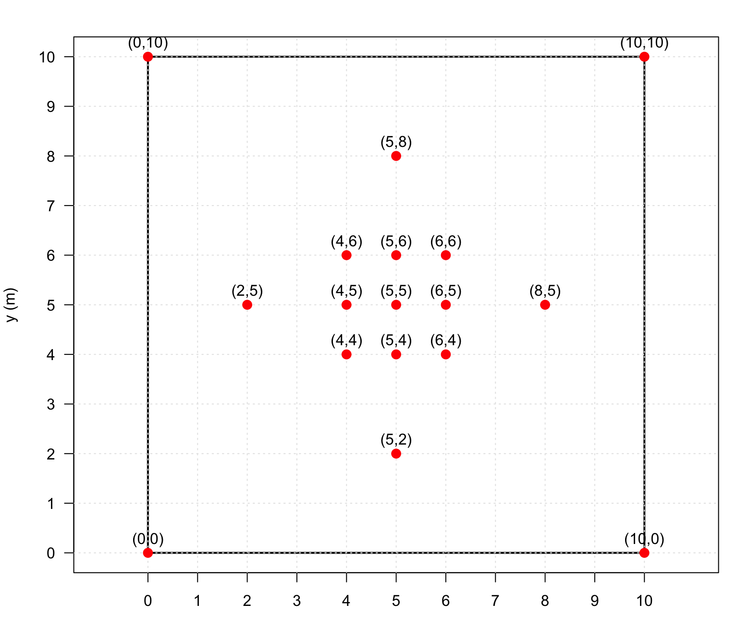
Figure 2: Relative distribution of sampling points over each 10 x 10 m sampling area, showing coordinates of each sampling point (x, y).

4. Establishing sampling grids in the field

The accuracy of hand-held GPS units is most likely not sufficient for use in establishing sampling grids. Therefore, the best way to establish such grids is using a low-teach method with tape measures, compass bearings and relative coordinates as described below.
Kit required
- For ice: x4 ice screws or e.g. hex screws + hand-held driver. For snow: x4 ‘markers’ – could be ice screws, or simple wooden stakes, bamboo stakes, e.t.c
- At least one tape measure, minimum 15 m length (best would be to have x3, 1 at 15 m, and two smaller ones to 5 m)
- Compass (could be pocket compass, or digital compass on phone/gps unit)
- Garden twine or similar, minimum 50 m
- Snow/ice sampling gear (see section 5 below)
Procedure:
- Establish your bottom left-hand corner position (0,0). Mark with an ice screw / stake. Record the GPS coordinates of this origin for georeferencing.
- Using a compass, take a bearing directly up glacier (or e.g. north if working in a snowpack, or south in southern hemisphere). Record the bearing for georeferencing, being careful not to hold metal objects near the compass. Take 3 readings to identify any anomalous readings,
- Walk exactly 10 m along this bearing (one person stays on 0,0 holding one end of the tape, the other walks out with the other end of the tape to 10 m exactly), mark the top left corner (0,10) with an ice screw/stake.
- Go back to 0,0, take a bearing at 90o to your original and walk out 10 m along this bearing to mark the bottom right corner (10, 0) with an ice screw/stake
- From the bottom right corner (10,0), use the original bearing and tape to walk out 10 m and mark the final top right corner (10,10) with an ice screw/stake.
- Check your 10 x 10 m square is actually square – each side should be 10 m long, and the diagonals should both be 14.14 m long. Adjust your corner markings as best possible if out of square.
- Once happy, delineate the edge of the sampling area by tying the garden twine or string/rope from corner marker to corner marker - this will help as a guide for subsequent sampling.
- Sample all four corner positions
- Go back to the bottom of the grid. Use the left- and right-hand-side twine lines to progressively guide you through the remaining samples, working from the bottom of your grid upwards as follows.:
  - Measure 2 metres up the left hand twine from position 0,0, and two metres up the right hand twine from position 10,0 (easier to do with the 2 smaller tape measures), stretch the longer tape measure across these two points from the left twine to the right twine, sample directly in the middle at 5 m (position 5,2).
  - Measure another 2 metres up the left and right hand twines (to 4 metres total), stretch a tape measure from left to right across these two points, and sample at 4 metres (4,4), 5 metres (5,4) and 6 metres (6,4).
  - Measure another 1 metre up the left/right hand twines (to 5 m total), stretch a tape from left to right and sample at 2 (2,5), 4 (4,5), 5 (5,5), 6 (6,5), and 8 (8,5) metres.
  - Measure another 1 metre up the left/right hand twines (to 6 m total), stretch a tape from left to right and sample at 4 (4,6), 5 (5,6), and 6 (6,6) metres.
  - Finally, measure another 2 metres up the left/right hand twines (to 8 m in total from the bottom corners, or 2 m from the top corners), stretch the tape from left to right and sample at 5 m (5,8).
This sampling design should prevent destruction of ice/snow surfaces prior to sampling, with the samplers progressively moving from bottom to top of the grid. This will require a minimum of two people working together in a coordinated manner.

5. Taking individual samples
Kit required:
- Sufficient number of sterile sampling bags (we use Whirl Pak Bags, 15 cm × 23 cm). Much better if these are pre-labelled and put into a logical order that matches your sampling design. We can send these to field teams as needed
- GPS unit to take coordinates (as best possible) of each sample point
- Camera (file format set to RAW) to image snow/ice surface prior to sampling (take a video of the sampling area as well if possible)
- Colour chart to include in images – please purchase a 24-color Calibrite ColorChecker if possible for this.
- Note-book / phone app to record all details with pencil/sharpy pen
- Sampling template – (3D printed templates to be sent to all teams from Bristol)
- For snow: rigid plastic sheet slightly larger than the sampling template
- For ice: bevel edged chisel to sample the ice and a small plastic scoop
- Wash bottle of some description to wash equipment between samples
- Dry bag to store sets of samples
- Larger backpack to carry samples out of the site
Procedure:
Prior to sampling, please take landscape-scale images/videos to provide the context of your wider sampling area. These could be done after delineating the 10 x 10 m sampling area with twine. Please also take general contextual notes on your sampling location, the timing of your sampling and e.g. the weather, e.t.c.
Per individual snow/ice surface sample:
- Image the snow/ice surface with a colour chart placed adjacent to the sampling area. Please make sure Image from above (nadir), making sure there are no shadows and the colour chart is fully captured. Please save all images in RAW format where possible.
- Record a GPS measurement of the sample location (on the most precise device you have to hand)
- Take any other pertinent notes (time of sampling, …)
- For snow: gently press the sampling template into the snowpack until it is flush with the surface, use a plastic sheet to cut/slice directly under the template so that you can remove the template and the snow it contains, place this into a sample bag. Seal and place into the dry bag.
- For ice: place the template onto the ice surface and cut around its otter edge using the chisel to delineate the sampling area. Remove the template and carefully use the chisel to extract the ice within the area down to 2 cm depth - we find using the chisel bevel up is the easiest way to achieve a uniform depth of sampling. This is simply done by pushing the chisel along by hand into the sampling area from one edge. Intermittently collect the sampled ice using the plastic scoop into the sample bag. Use the template (which is 2 cm deep) to check you have sampled down to the right depth. Seal the sample bag and place into the dry bag.
- Clean all sampling tools between samples by rinsing well with water

Transport all samples back to ‘base’ and distribute them for melting over the next 24 – 48 hours (see below).

6. Melting samples
All samples should be melted slowly in the dark for 24 – 48 hrs at positive but cool temperatures (ideally ~4ºC). **do not freeze the samples in a freezer for later processing as this can cause the cells to rupture.
If you have access to a large fridge, distribute the samples within the fridge for melting. The closer the samples are to one another, the longer they will take to melt. Moving samples around and giving the snow/ice a mix through the bag helps to speed up the process.
If you do not have access to a fridge, please melt the samples as best possible in the dark. If in a cold climate, this could be outside in the shade/covered with black plastic bags. If in a warmer climate, inside room temperature melting is also OK.
Samples must be 100% melted before they can be processed (see below). Please make a note of the conditions under which you melted your samples.

7. Processing samples
For each fully melted snow/ice sample:
- If possible, please weigh the all samples to the nearest milligram before further processing.
- Mix the sample as best possible *this is a very important step so that we get representative counts*. You can do this by shaking, swirling, etc. Sometimes it is necessary to rub the two sides of the plastic sample bag together between your fingers to liberate cells that have stuck to the inside of the bags and get them back into suspension in the meltwater. Please do this if you see a residue on the inside of the bag near the water line.
- Immediately after mixing the sample, use a plastic Pasteur pipette (we can send these to everyone) or similar to transfer 2 mL of sample into a 2 mL eppendorf tube (we can also send these out). Use the graduations on the side of the tube to guide you (or ideally use a precise pipette). You can also use the pipette to keep mixing the melted sample during this process.
- Add 10 µL of Lugols solution (1% final volume) to your 2 mL of sample (we can send Lugols to people). If you do not have access to a micropipette to do this accurately, use a plastic Pasteur pipette to add exactly 1 drop of lugols solution to your 2 mL sample. Record for each sample how much Lugols was added please.
- Close the tube and seal the lid with electrical tape.
- Make sure the tube is properly labelled with an easy-to-read label (see section 8 below).
- Store in a cool, dark place until sending on to Bristol or counting cells yourself.

8. Preferred labelling conventions
To simplify the labelling of samples, we recommend that each sample bag should use the following labelling convention. As the 2 mL Eppendorf that samples will ultimately end up in are very small, it is likely these will need to just be labelled with simple letter/number conventions (e.g. S1, S2, S3,…) – please make sure to keep a detailed sample log to relate each tube name to the details below:
YEAR-MONTH-DAY_SITE INITIALS_GRID NUMBER_GRID COORDINATE
e.g. 2026-04-08_MORT_01_0,0 is the sample from location 0,0 of the first sampling grid, on Morteratsch glacier, on 8th April 2026.
e.g. 2027-02-01_S6_05_5,5 is the sample from location 5,5 of the fifth sampling grid, from site S6, on 2nd February 2027.

9. Field/processing consistency
- Use the same support size and collection depth definition at all sites.
- Keep labelling convention identical across samples.
- Record any departures from the standard method explicitly in the metadata sheet.
- Where surface conditions make the standard approach impossible, document the reason and the modified method used. **some teams may need to adjust sampling design if the sampling area is less than 10 x 10 m, please make sure to document your sampling design well if it differs from the main guidance here.

10. Optional enhanced measurements
If field teams have access to the equipment below, it would add extra layers to the datasets produced that would be very beneficial, but we are assuming that teams will not have such access. If teams do have access to such kit, we are also assuming that they are fully trained in how to deploy it.
- Differential GPS – using the low-tech method of grid delineation detailed above but then recording the precise location of each sampling point using a dGPS would be very informative as to the relative accuracy of teams when using the low-tech approach.
- Complementary drone imagery of the sampling area (ideally performed before sampling and with adequate overlap of images for DEM production)
- Spectral reflectance measurements of snow/ice surfaces prior to sampling. N.B. we note that to do this properly would take way too much time versus the number of replicates we are aiming for, but this could make a nice complimentary dataset for a smaller number of samples taken at the same site at a time close to the main sampling day.
- Field microscopy - If you have a dinolite or similar it is always handy to have a field ID/direct imagery of the sampled surface as some cells do lyse when warmed in the lab microscope?

9. Support and collaboration model
The initiative is a community effort organized and supported as much as possible by the CASP-ICE project (www.casp-ice.org.uk). CASP-ICE can provide the following:
- Consumables for sampling and preserving samples can be provided where required including garden twine, sample bags, colour chart, sampling templates, sample tubes, lugols solution and Pasteur pipettes.
- The counting of cells from all and any samples at the University of Bristol, but teams are of course welcome to count their own samples and it would be nice to do some intercomparisons between laboratories.
- Colleagues in the wider network will kindly explore complementary remote-sensing products.

10. Indicative timeline
Period | Planned activity
March–April 2026 | Agree and document sampling protocols; circulate live draft for comment.
May 2026 | Send out any sampling kit required.
Spring/Summer 2026 onwards | Field teams deploy and collect samples.
Ongoing during and after field seasons | Associated satellite-data exploration and processing for sites/times where possible.
As samples arrive | Samples read either at home institutions or in Bristol on a first-come, first-served basis.
Spring 2027 | Target timing for paper submission/publication

